**CREATING THE BASE OBJECT**

1. Create and object called **Travel**

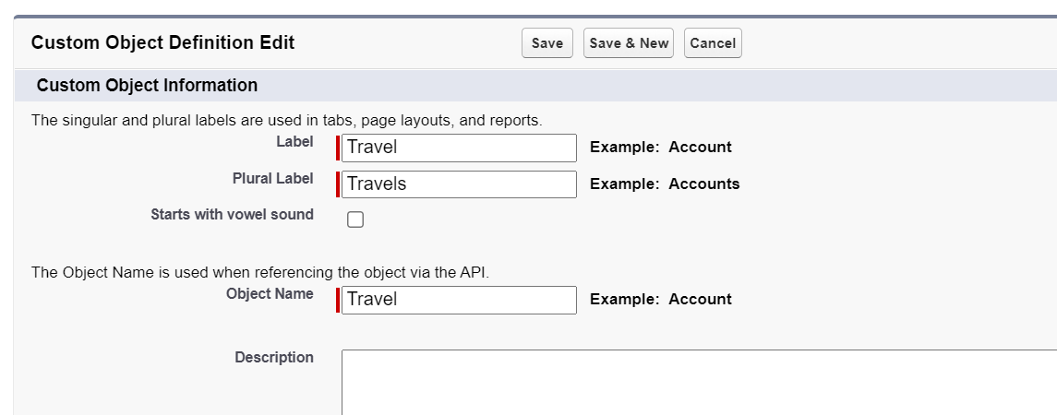

1. Add custom tab by selecting the option.

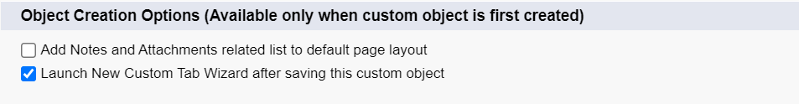

1. Add blue theme would be used.

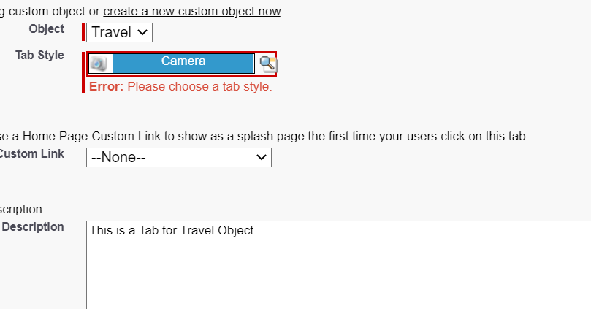

1. …. Next…. Save.
2. Create a Lightning App. using App Manager.

From Setup,

Enter App Manager in Quick Find and select App Manager.

Click New Lightning App.

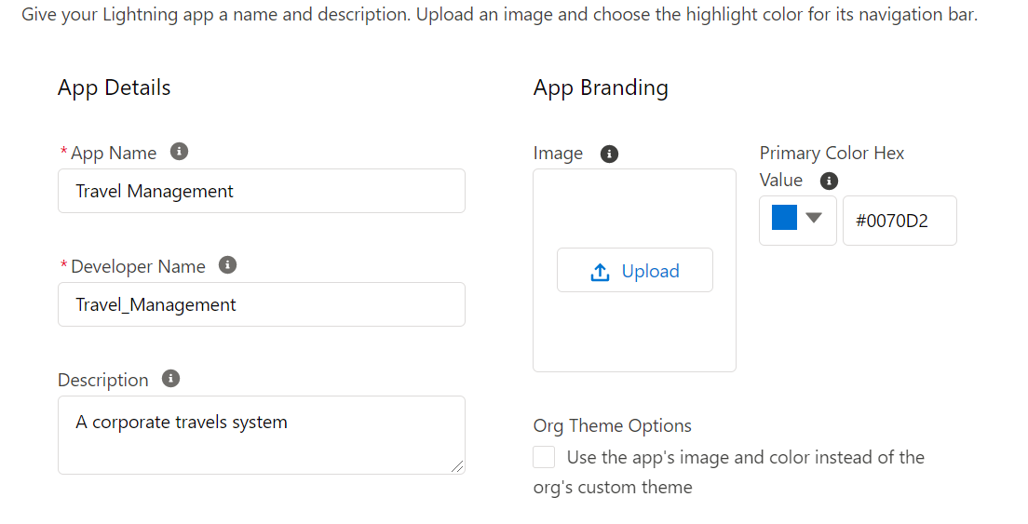

Select Travels.

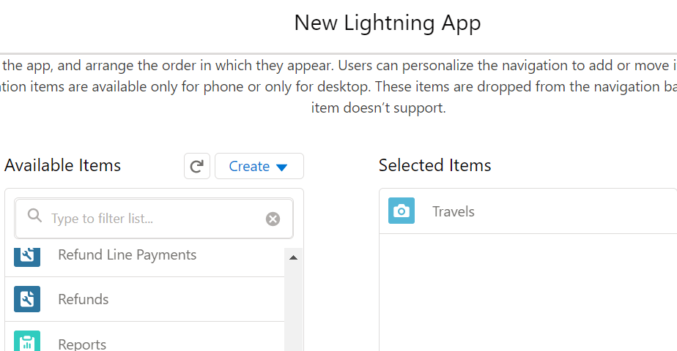

1. Select user roles that can access the app. Select system administrator for now.

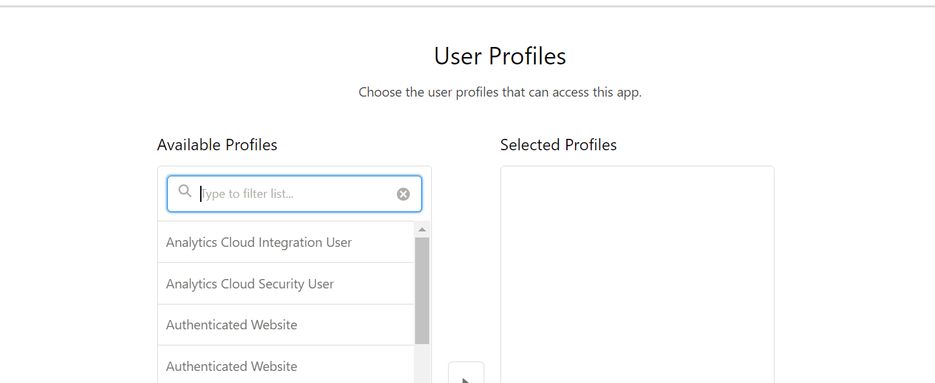

1. Check the app out.

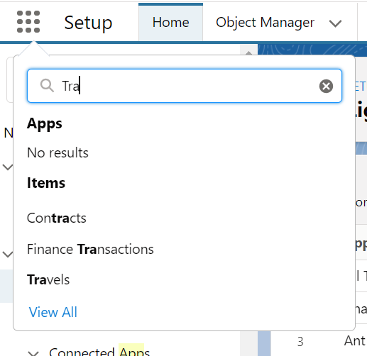

First Task Completed.